Game Design Document

Fill up the following document

1. Write the title of your project.

Medival castle wars

1. What is the goal of the game?

To farm, sell get enough xp and then battle

1. Write a brief story of your game.

The starting screen will have 4 buttons – Help : which explains the game rules, War : which can only be accessed after reaching level 50, Farm : Where you have 3 different vegetables – Carrots, Cucumber, Potatoes. The last button is Market – Here you sell the crops you have grown and you make money and xp for levels.

Once you do reach the minimum level for war then you will receive a basic gun and you have to navigate through a maze and battle many evil foes and at the end of the maze you will have the enemy castle, you must destroy their crystal.

1. Which are the playing characters of this game?

* Playing characters are the ones who respond to the user based on the input from the user.
* Cars, monkeys, dinos, wizards, etc., are the playing characters in the game.

|  |  |  |
| --- | --- | --- |
| Number | Character Name | What can this character do? |
| 1 | Yourself – (survivor) | Farm, War, Market |

1. Which are the Non-Playing Characters of this game?

* Non-Playing characters are the ones that don't have an action or behavior when the user interacts with the game.
* Hurdles, stones, bananas, coins, etc., are non-playing characters in the game.

|  |  |  |
| --- | --- | --- |
| Number | Character Name | What can this character do? |
| 1 | Enemy foe level 1 | He can shoot in the war and deal 1 hp damage to the player.  (The player has 100 hp)  After he is killed he drops his weapon which is better than the default weapon.  He can shoot every 5 seconds |
| 2 | Enemy foe level 2 | He can shoot in the war and deal 5 hp damage to the player.  (The player has 100 hp)  After he is killed he drops his weapon which is better than the current weapon the player has.  He can shoot every 3 seconds |
| 3 | Enemy foe level 3 | He can shoot in the war and deal 10 hp damage to the player.  (The player has 100 hp)  After he is killed he drops his weapon which is better than the current weapon the player has.  He can shoot every 2 seconds |
| 4 | Gaurdian of the evil crystal | He can shoot in the war and deal 15 hp damage to the player.  (The player has 100 hp) |
| 5 | Evil crystal | It cannot do anything to the player. The player must destroy the crystal using their gun |

Draw your imagination of this game. What does this game look like?

* Draw the game either on your computer or on paper.
* Add images of the game scenes to show each of the playing and non-playing characters at least once.

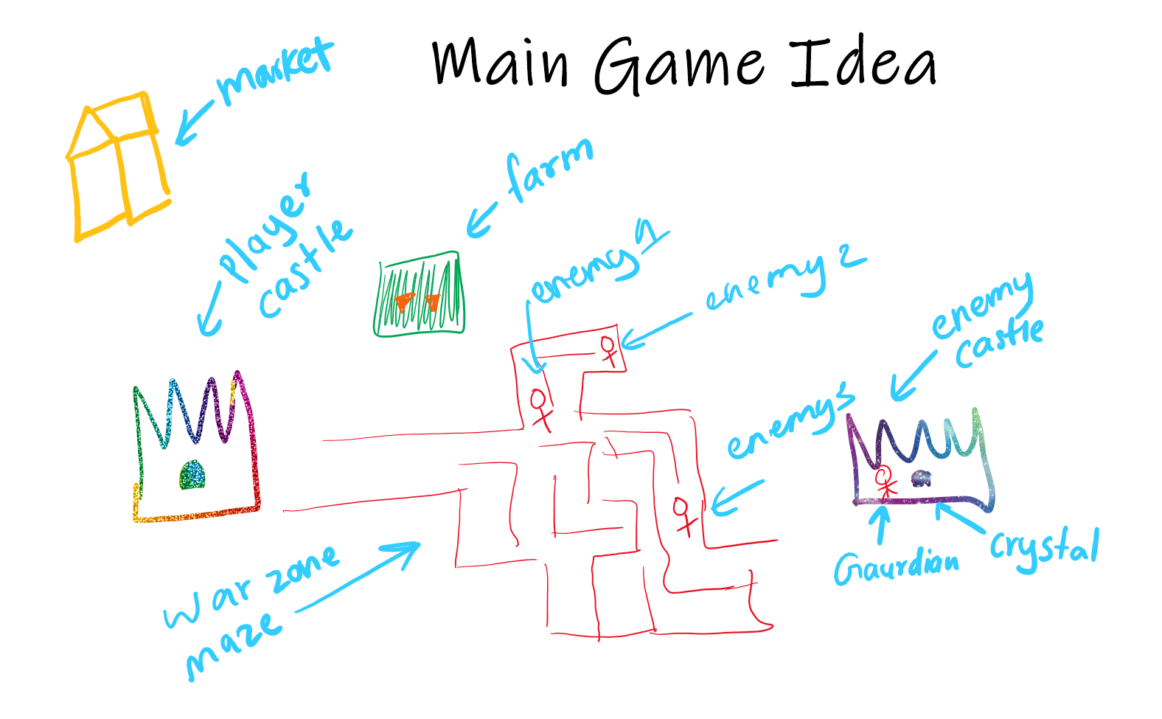

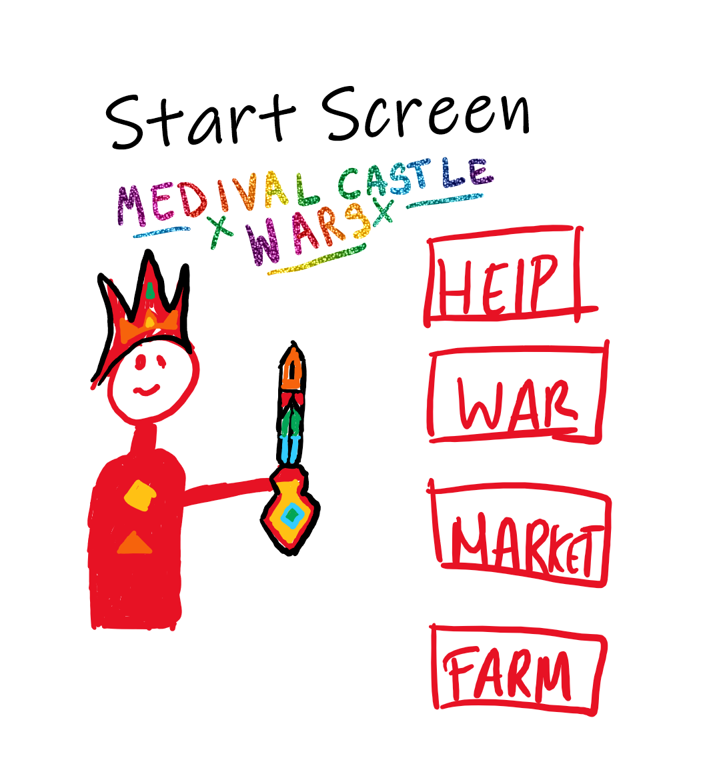

How do you plan to make your game engaging?

I plan to make my game more enaging by itroducting different modes like – easy, normal, difficult. Etc.

I also want to add more enemy castles.

I will be using Visual studio code.